Q. Demonstrate the RIP Routing in Packet Tracer.

Aim: To configure and demonstrate RIP dynamic routing protocol between two networks using two routers in Packet Tracer.

Steps:
1.In packet tracer place 2 PCs and 2 Routers.
2.Connect Router0 with PC0 via FastEthernet0/0 using cross-copper cord and Router1 with PC1 via FastEthernet0/0 using cross-copper cord.
3.Connect both routers via FastEthernet0/1 using cross-copper cord.
4.Set the IP address and default gateway of both the PCs in IP configuration of both PCs respectively.
5.Configure RIP version 2 routing protocol on both routers.

Topology :
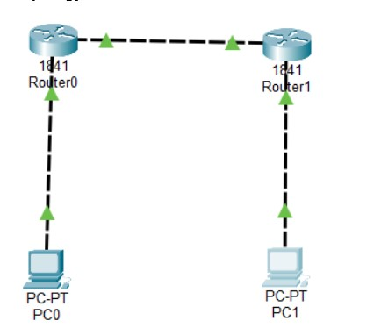
Code:
Router0 Configuration:
Router>enable
Router#configure terminal
Router(config)#hostname Router0
Router0(config)#interface FastEthernet0/0
Router0(config-if)#ip address 192.168.10.1 255.255.255.0
Router0(config-if)#no shutdown

Router0(config-if)#exit
Router0(config)#interface FastEthernet0/1
Router0(config-if)#ip address 10.10.10.1 255.255.255.0
Router0(config-if)#no shutdown
Router0(config-if)#exit
Router0(config)#router rip
Router0(config-router)#version 2
Router0(config-router)#network 192.168.10.0
Router0(config-router)#network 10.10.10.0
Router0(config-router)#no auto-summary
Router0(config-router)#exit
Router0(config)#exit
Router0#copy running-config startup-config

Router1 configuration:
Router>enable
Router#configure terminal
Router(config)#hostname Router1
Router1(config)#interface FastEthernet0/1
Router1(config-if)#ip address 10.10.10.2 255.255.255.0
Router1(config-if)#no shutdown
Router1(config-if)#exit
Router1(config)#interface FastEthernet0/0
Router1(config-if)#ip address 172.16.20.1 255.255.255.0
Router1(config-if)#no shutdown
Router1(config-if)#exit
Router1(config)#router rip
Router1(config-router)#version 2
Router1(config-router)#network 10.10.10.0
Router1(config-router)#network 172.16.20.0
Router1(config-router)#no auto-summary
Router1(config-router)#exit
Router1(config)#exit
Router1#copy running-config startup-config

PC0 Configuration:
IP Address: 192.168.10.2
Subnet Mask: 255.255.255.0 Default Gateway: 192.168.10.1 PC1 Configuration:
IP Address: 172.16.20.2
Subnet Mask: 255.255.255.0
Default Gateway: 172.16.20.1

PCO Command Prompt :
C:\>ipconfig
C:\>ping 192.168.10.1
C:\>ping 10.10.10.1
C:\>ping 10.10.10.2
C:\>ping 172.16.20.1
C:\>ping 172.16.20.2

PCO Command Prompt :
C:\>ipconfig
C:\>ping 172.16.20.1
C:\>ping 10.10.10.2
C:\>ping 10.10.10.1
C:\>ping 192.168.10.1
C:\>ping 192.168.10.2

Router Verification Commands:
Router0#show ip route
Router0#show ip protocols
Router0#show ip rip database
Router1#show ip route Router1#show ip protocols

OUTPUT :
PC0 OUTPUT :
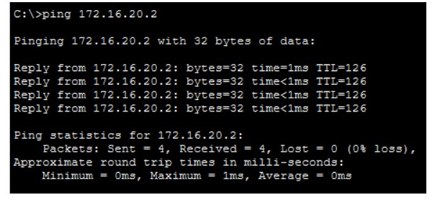

PC1 OUTPUT :
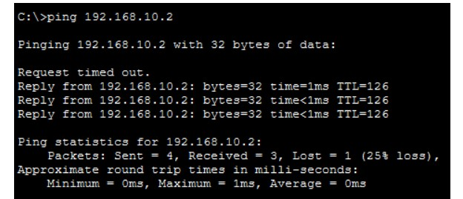

IP ROUTE OUTPUT :
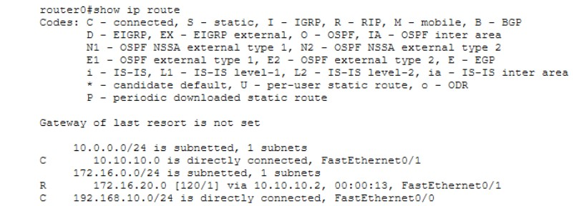

RIP PROTOCOL OUTPUT :

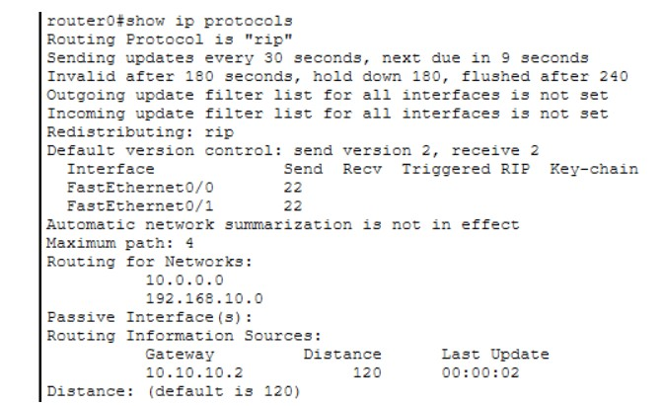

CONCLUSION : The above network topology has been executed successfully and RIP version 2 dynamic routing has been demonstrated.

